Metallurgy Europe Call-03-2019
Full Project Proposal (FPP)
(Confidential)

Call Identifier Code: Met-Euro-Call-03-2019

Full Title of Project: XXXX

Acronym/Short Name: XXXX

Submission Date: DD-MM-2019

Coordinating Organisation: XXXX (Country)

Technical Coordinator’s Signature:

Contents Page
Page #
1) Short Abstract x
2) Project Features x
3) Coordinator Details x
4) Proposed Consortium x
5) Product Description x
6) Market Outline x
7) Patent Status x
8) Value Chain x
9) Project Objectives x
10) Technical Strategy x
11) Technology Readiness Levels x
12) Speed of Market Entry x
13) European Autonomy x
14) Efforts towards Standardisation x
15) Work-Package Breakdown x
16) Work-Package Descriptions x
17) Project Gantt Chart x
18) Cost Estimates per Partner x
19) Management Structure x
20) Management of IP & Research Data x
21) Risk Analysis x
22) PR, Dissemination & Training x
23) Impact on Society x
24) References x
Annex – All Evaluation Criteria for Stage 2 FPPs x
Full Project Proposal

1) Short Abstract:
Please describe your project proposal in this box (maximum ½ page):
XXXX

Please describe the relevance of your proposal to Metallurgy Europe and its roadmap:
XXXX

2) Project Features:

Estimated total budget (M€): XX
Estimated person years: XX
Full duration of project (yrs): X
Number of partners in team: XX
Number of countries involved: XX

3) Coordinator Details:

Full Name of Technical Coordinator: XXXX
Organisation Name: XXXX
Organisation Address: XXXX
Email Address: XXXX
Telephone Number: XXXX
Website: XXXX

4) Proposed Consortium:

# | Partner Organisation | Country | Industry / Gov. R&D / University | Company Size (Large or SME?) | Technical Representative
1
2
3
4
5
6
7
8
9
10
11
12
13
14
15
16
17
18
19
20
21
22
23
24
25
26
27
28
29
30
31
32
33
34
35
5) Product Description:

Max. 1 page
Please describe the new industrial product(s) that this proposal is attempting to deliver.
Please emphasise:
(i) why this new product is needed,
(ii) what technical and societal problems it solves, and
(iii) how it is different to the state-of-the-art technology used today.

6) Market Outline:

Max. 1 page
Please describe the market status in this particular technical field.
Please identify:
(i) who the competitors are around the world,
(ii) how big is the world market for this type of product, and what is the current European share (in %),
(iii) what is the expected increase in turnover of the European partners, if the product is successfully developed and industrialised,
(iv) why this proposal offers a competitive edge, from a global perspective.

7) Patent Status:

Max. ½ page
Please provide a general overview of the patent status and proprietary know-how in this field.
Please identify Europe’s position with respect to this IP.

8) Value Chain:

Max. ½ page
Please provide a schematic diagram of the value chain.
In this diagram, please highlight where the industrial partners sit, and ensure that each industrial partner has a market opportunity within this value chain.

9) Project Objectives:

Max. ½ page
Please list in bullet-points the main technical objectives of your proposal.
Please ensure your objectives are clear and quantifiable.
- Xxx
- Xxx
- Xxx
- Xxx
- Xxx
- Xxx
- Xxx

10) Technical Strategy:

Max. 2 pages
Please describe the technical strategy and general planning of your proposal.
Please identify any particular phases of work, as well as the main hardware/software deliverables.
Please identify any linkages with other Metallurgy Europe projects/proposals.

11) Technology Readiness Levels
Max. ½ page
Please define where the overall project lies on the TRL scale (e.g. TRL 4 to 7, as below).
At which TRL does the project begin, and where will it end, at project completion?

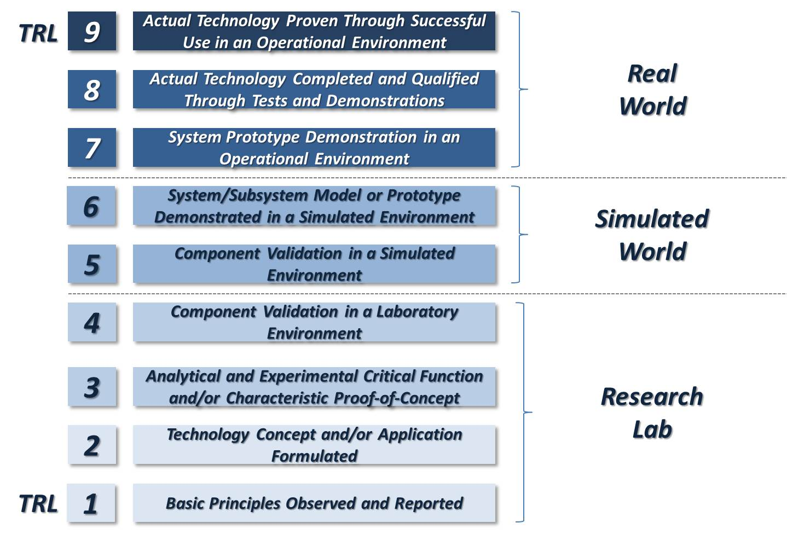
End of project
Start of project

12) Speed of Market Entry
Max. ½ page
Please describe how quickly the new product/hardware/software can be brought to the market.

13) European Autonomy
Max. ½ page
Please describe the European dimension of the new supply chain being proposed, including where relevant other Associate Eureka Countries like Canada and South Africa.
Highlight, where possible, current bottlenecks in the supply chain (e.g. dependency on foreign supply) that could be overcome by purposefully promoting European R&D, suppliers and producers.
On a scale from 1-10, how much European autonomy is expected by the end of the project? (10 being the highest level of European autonomy)

14) Efforts Towards Standardisation
Max. ½ page
Please briefly mention any efforts in the project that would promote the use of best-practice, normalisation and standardisation (ISO, CEN, ASTM).
Please also highlight any standards that are currently missing and impeding industrial take-up.

15) Work-Package Breakdown:

Max.2 pages
Please provide a list of the different workpackages (e.g. WP1…WP10)
Please provide a pictorial description of the workpackages and how they link together.
Please fill out the WP/partner matrix overleaf (i.e. who does what?)

# | Partner Short Name | WP1 | WP2 | WP3 | WP4 | WP5 | WP6 | WP7 | WP8 | WP9 | WP10
 |  | Xxx | Xxx | Xxx | Xxx | Xxx | Xxx | Xxx | Xxx | Xxx | Xxx
1
2
3
4
5
6
7
8
9
10
11
12
13
14
15
16
17
18
19
20
21
22
23
24
25
26
27
28
29
30
16) Work-Package Descriptions:
Please provide a more detailed description of each work-package listed in Section 15, using the table below.

Work-Package 1
Title:
List of All Partners:
WP Lead Partner:
Start and End Date: | Month 1 – Month X
Short Description of Work:
xxxx

List of Main Deliverables, Hardware & Software:
- D1-1 (in Month X)
- D1-2 (in Month X)
- D1-3 (in Month X)
Work-Package 2
Title:
List of All Partners:
WP Lead Partner:
Start and End Date: | Month 1 – Month X
Short Description of Work:
xxxx

List of Main Deliverables, Hardware & Software:
- D2-1 (in Month X)
- D2-2 (in Month X)
- D2-3 (in Month X)

Work-Package 3
Title:
List of All Partners:
WP Lead Partner:
Start and End Date: | Month 1 – Month X
Short Description of Work:
xxxx

List of Main Deliverables, Hardware & Software:
- D3-1 (in Month X)
- D3-2 (in Month X)
- D3-3 (in Month X)

Work-Package 4
Title:
List of All Partners:
WP Lead Partner:
Start and End Date: | Month 1 – Month X
Short Description of Work:
xxxx

List of Main Deliverables, Hardware & Software:
- D4-1 (in Month X)
- D4-2 (in Month X)
- D4-3 (in Month X)

Work-Package 5
Title:
List of All Partners:
WP Lead Partner:
Start and End Date: | Month 1 – Month X
Short Description of Work:
xxxx

List of Main Deliverables, Hardware & Software:
- D5-1 (in Month X)
- D5-2 (in Month X)
- D5-3 (in Month X)

Work-Package 6
Title:
List of All Partners:
WP Lead Partner:
Start and End Date: | Month 1 – Month X
Short Description of Work:
xxxx

List of Main Deliverables, Hardware & Software:
- D6-1 (in Month X)
- D6-2 (in Month X)
- D6-3 (in Month X)

Work-Package 7
Title:
List of All Partners:
WP Lead Partner:
Start and End Date: | Month 1 – Month X
Short Description of Work:
xxxx

List of Main Deliverables, Hardware & Software:
- D7-1 (in Month X)
- D7-2 (in Month X)
- D7-3 (in Month X)

Work-Package 8
Title:
List of All Partners:
WP Lead Partner:
Start and End Date: | Month 1 – Month X
Short Description of Work:
xxxx

List of Main Deliverables, Hardware & Software:
- D8-1 (in Month X)
- D8-2 (in Month X)
- D8-3 (in Month X)

Work-Package 9
Title:
List of All Partners:
WP Lead Partner:
Start and End Date: | Month 1 – Month X
Short Description of Work:
xxxx

List of Main Deliverables, Hardware & Software:
- D9-1 (in Month X)
- D9-2 (in Month X)
- D9-3 (in Month X)

Work-Package 10
Title:
List of All Partners:
WP Lead Partner:
Start and End Date: | Month 1 – Month X
Short Description of Work:
xxxx

List of Main Deliverables, Hardware & Software:
- D10-1 (in Month X)
- D10-2 (in Month X)
- D10-3 (in Month X)

17) Project Gantt Chart:
Please provide a simplified 1-page Gantt chart for the duration of the project, highlighting the major achievements expected.

18) Cost Estimates per Partner:
Please provide estimates of resources per partner, for the full duration of the project.
# | Partner Organisation | Number of Person Years | Labour costs (k€) | Materials costs (k€) | Equipment costs (k€) | Total costs (k€) | Public coverage rate (%) | § Have the PAB been contacted yet ?
1
2
3
4
5
6
7
8
9
10
11
12
13
14
15
16
17
18
19
20
21
22
23
24
25
26
27
28
29
30

§ www.eurekanetwork.org/in-your-country (web-link for public authorities contacts per country)

Self-Funding Partners:
Please list any project partners that wish to self-fund themselves, in the absence of any public co-funding. (N.B. Funding from Horizon2020 cannot be used here, since this would constitute double usage of funds)

19) Management Structure
Max. 1 page
Please provide a simple organigramme showing the management structure of the project, including project coordinator, WP coordinators etc.
Briefly describe the general governance, and how collective decision will be made.

20) Management of IP & Research Data
Max. ½ page
Please outline how the IP and R&D data will be managed in the project. The guiding principle is, of course, that the originating inventor(s) will own the invention and therefore the right to patent via their organisations. Joint patenting is also permissible. In some cases, trade secrecy may be a better course of action, rather than a patent disclosure.
Will there be any databases created to house the new project data, and how will this be owned, shared, accessed, maintained, licenced etc.?

21) Risk Analysis
Max. ½ page
Please highlight in the table below any important risks that the project could face.

# | Risk | Probability | Impact | Possible Back-Ups
1 | xxx | low/medium/high | low/medium/high
2 | xxx | low/medium/high | low/medium/high
3 | xxx | low/medium/high | low/medium/high
4 | xxx | low/medium/high | low/medium/high

22) PR, Dissemination & Training:
Max. ½ page
Please describe any public engagement and dissemination activities that are planned (e.g. open days, lectures, public talks, trade-fairs, conferences etc.)
Please outline how the industry partners can promote technical training and apprenticeships in this field. Company work-placements for students are welcomed and urged, as a way of getting more young people involved in engineering, materials and industry. So please mention any particular efforts or possibilities for interns, stagiaires, trainees etc. within the project.

23) Impact on Society:

Max. 1 page
Please provide a layman’s description of how this proposal can bring benefits to the average person in society (e.g. less pollution, fuel savings, better healthcare, cheaper products etc.).
N.B. This non-confidential text will be published on the Metallurgy Europe website, at a later date.

24) References:

Max. ½ page
Please provide any references, relevant web-links or background information here.

Annex – All Evaluation Criteria for Stage-2 FPPs

1) Scientific & Technical Quality (10 points)
- relevance to the specific call and the Metallurgy Europe roadmap
- clarity of project objectives, in a quantified way
- overall novelty, creativity and originality, beyond the state-of-the-art
- soundness and coherency of scientific/technical work-plan
- clarity of start and end TRLs

2) Quality of Partnership (10 points)
- quality of individual partners, and quality of team as a whole
- European dimension, namely minimum 4 different EMSs
- appropriate balance between multinationals, SMEs and academic support
- technical complementarity and integration between different partners
- good market opportunities for each partner in the value chain

3) Industrial Impact (10 points)
- level of industrial ambition, as well as end-user pull
- relevance of project to global market needs
- likelihood of making a positive contribution to Europe's GDP
- speed at which the new product can be brought to the market
- development of a European-autonomous supply chain
- efforts towards normalisation and standardisation (ISO, CEN, ASTM)

4) Societal Impact & Engagement (10 points)
- impact on society and the quality of life of the average citizen
- level of public engagement (open days, lectures, trade fairs)
- PR and communication of results
- training of apprentices and technicians
- company work placements for students and interns

5) Management Approach (5 points)
- clarity and coherency of workpackages, incl. realistic manpower allocation per partner
- appropriateness of management structure and governance
- management of intellectual property and research data
- risk analysis table
- robustness, in case of partners' withdrawal

6) Appropriateness of Budget (5 points)
- reasonable budget split between partners and tasks
- good overall value-for-money
- appropriate listing of major cost items (>50k€)
- budget allocation for patenting, design rights and trademarks
- have the Public Authorities been duly contacted ?

